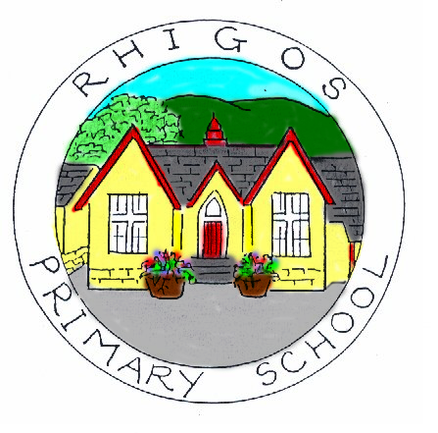Ysgol Gynradd Rhigos Primary School Toilet Policy
This document is freely available to the whole school community.
Aims:
- To maximise access to learners’ toilet facilities during the day to promote the health,
- To provide good quality toilet facilities throughout the school.

Rationale:
- The school recognises that well-maintained toilet facilities where learners feel comfortable and safe and have open access to throughout the school day, are essential for health,
well-being and learning.
- We value and respect our learners and want them to be able to benefit from good provision and practice.

Objectives:
- To ensure that this policy is both accepted and upheld by whole-school community –
school management, staff, learners, governors, parents/carers, site manager, cleaning and ancillary staff.
- To keep all toilets open and available to learners throughout the school day not just at break and lunch times if they need to, we ensure that learners have access at all times.
- To ensure that the toilet and washroom facilities are suitable for the range of anticipated users, including learners with disabilities and special needs, with adequate lighting, fixtures and fittings.
- To ensure that the toilet facilities provide visual and aural privacy for users, ensuring a spare supply of cubicle door locks.
- To ensure that all toilet areas have properly maintained supplies at all times of warm and cold water, liquid soap, hand drying facilities and toilet tissue in dispensers, provided at a convenient height.
- To ensure there are sanitary disposal units available.
- To implement and maintain an effective toilet cleaning, supervision and inspection regime to ensure standards of provision and cleanliness, throughout the school day.
- To locate drinking water supplies and outlets in safe and appropriate locations, and not in toilet areas.
- To allow the children to use the toilets as and when they need to.
- To consult with the wider community of the school in relation to any concerns about toilet provision.
- To actively consult and involve our pupils in managing the toilets.
- To encourage our pupils to respect toilets.
- To regularly include toilet management issues in all appropriate school council, staff, parent/carer and governor meetings.
- To implement annual reviews of the policy.

Chair of Governors: _________________________Headteacher:_____________________________

Date: _________________________________ Next review:______________________________

