**How does creativity explore a person’s Cynefin?**

Spring Term 2024

Class 1

Your child will have an opportunity to….

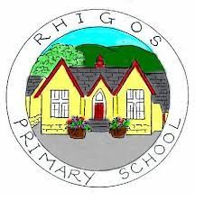

Important dates we will be learning about:

. Mari Lywd visit

. St. Dywnwens Day

. Children’s Mental Health week

. Safer Internet Day

During the Spring term, your child will have an opportunity to experience curriculum.

. Mathematics and Numeracy

. Languages, literacy and communication

. Health and Wellbeing

. Expressive arts

To learn about the colour wheel. Learn about warm and cool colours and the difference between primary and secondary colours. Colour mixing.

Drawing techniques. Mark making. Drawing textures. Sketching. Observation drawings.

Experience Welsh Folk Dancing

Understand the word Cynefin and what it means to the children.

Write facts about themselves in Welsh

Learn about different Welsh music artists and use instruments to make our own music.

Explore different Welsh artists and study their artwork.

Learn about Welsh traditions and participate in the school Eisteddfod.

Explore Welsh Mythical stories