

We will be focusing on the ‘Hatching’ drawing technique and completing observation drawings using this technique.

Class 2-Spring Term  
Throughout the upcoming Spring Term, your child will be immersed in a variety of experiences designed to encourage exploration and facilitate the acquisition of knowledge across a range of curriculum areas.

**Language, Literacy and communication.**

**Mathematics & Numeracy**

**Expressive Arts/ Health and Well being**

**We care, We believe, Together we will achieve.**

Children will have the opportunity to explain the techniques used in their artwork and participate in gallery walks to observe other artwork

Have opportunity to learn drama skills and use these during our Easter performance.

Learning and understanding traditional Welsh songs. Focusing on ‘Sosban Bach’. The children will be performing this using Makaton.

How does creativity explore a persons CYNEFIN?

To understand their cynefin and how they are a part of Rhigos and Wales.

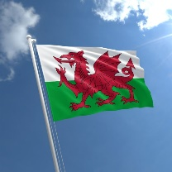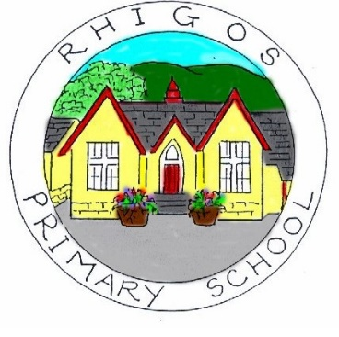

Research landmarks in Rhigos and Wales and sharing information we’ve found as a group

Explore colour focusing on primary, secondary and tertiary colours and how this impacts the mood of the art and exploring Welsh artists that use these colours.

Learning a traditional Welsh Folk Dance and performing ‘Cylch Y Cymru’.

Learn about Traditional Welsh celebrations and participate in a school/local Eisteddfod. Children have the opportunity to perform a poem in Welsh at the Regional Eisteddfod

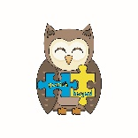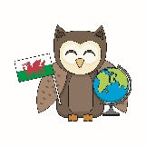

Class Novel

The Snow Spider

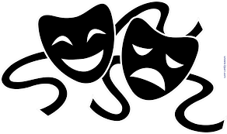

To explore Welsh mythical Stories and create their own.

Our story will be ‘Santes Dwynwen’

Use Purple Mash to retell the story of Saint Dwynwen.

**Important Events in the Spring Term that we will be celebrating/ learning about.**

**Mari Lwyd, ST Dwynwen’s Day, St David’s Day ,Children’s Mental Health Day, Internet safety day.**

**We will also be learning about the Easter story and producing a class assembly based on our learning.**

